Medical History Form

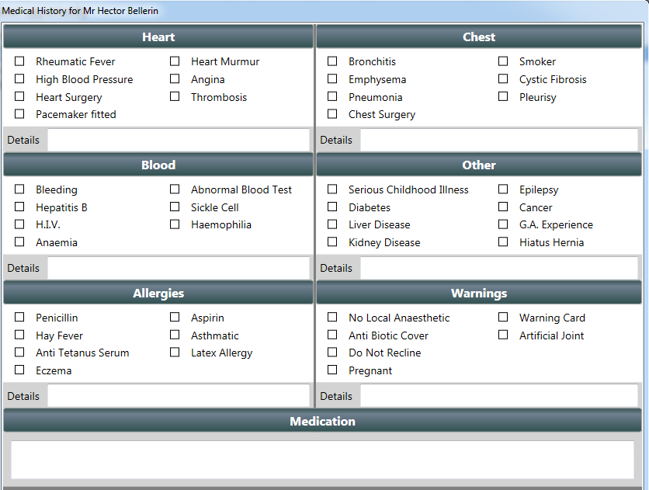

Signed: ………………………………………………………………………..

Date:_________________

